**ZONIONS APPLICATION**

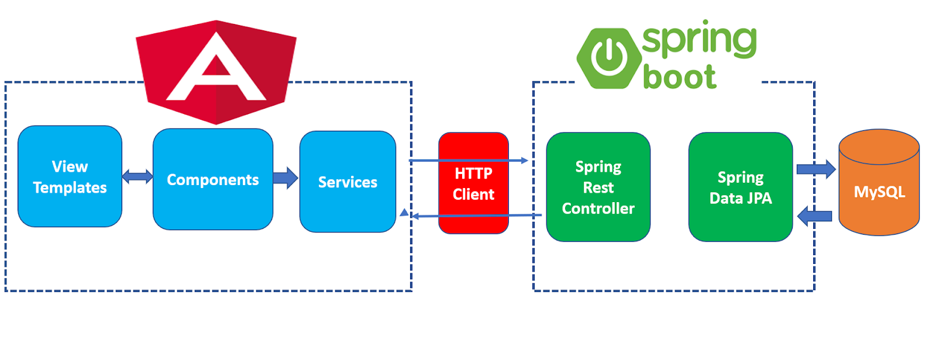

**Features Implemented**

* Create a Restaurant
* Update a Restaurant
* List of all the active Restaurants
* List of all the active as well as non-active Restaurants
* Delete Restaurant
* Admin Login
* Details of the Restaurant

**Technologies Used**

* **Springboot-jpa:** This project is used to develop CRUD RESTFul APIs for a simple **Restaurant Management System** using Spring Boot, JPA and MySQL as a database.
* **angular8**: This project is used to develop single page application using Angular 8 as front-end technology. This application consumes CRUD Restful APIs developed and exposed by a **springboot-jpa**.

## **Server-side technologies**

* Spring Boot – 2.4.1 RELEASE
* JDK – 1.8
* Spring Framework
* Hibernate
* Spring Data JPA
* My SQL Workbench 8.0

**Front-end technologies**

* Angular 8
* Bootstrap 4
* npm 6.14.8

**Tools**

* Spring Tool Suite-4(STS) - Spring Boot API Development
* Visual Studio Code 2019 - Angular App Development
* Angular CLI

Below are the screenshots shows UI of **Restaurant Management System App:**

**Login Page**

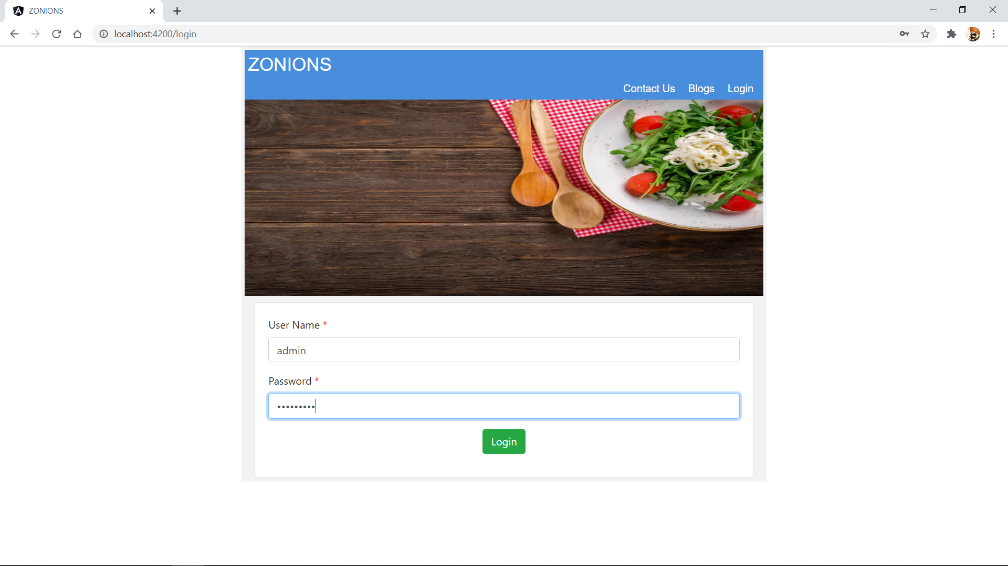

**Username:** admin

**Password:** admin@123

**Home Page**

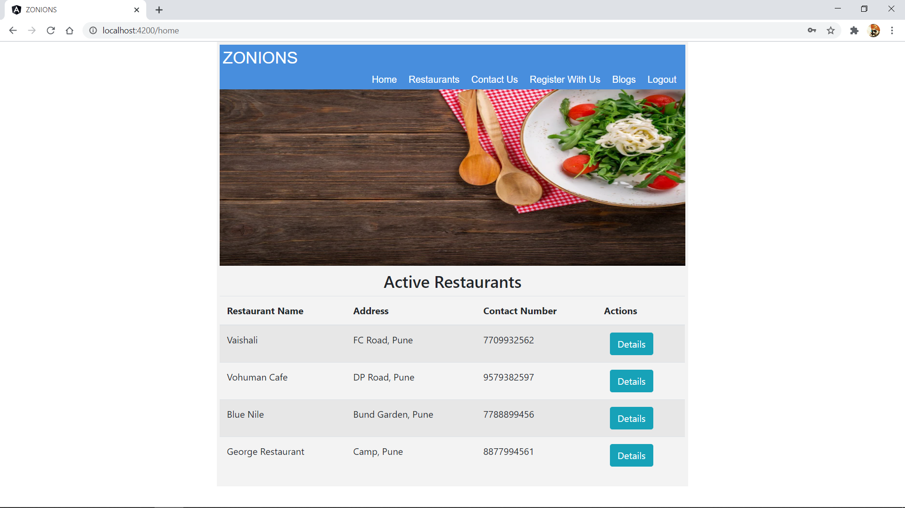

Home Page (Active Restaurants)

* Restaurant Name
* Address
* Contact Number
* Details Tab( this will guide us with all the details regarding a particular restaurant)

This tab will navigate us to restaurant details page.

**Restaurant Details Page**

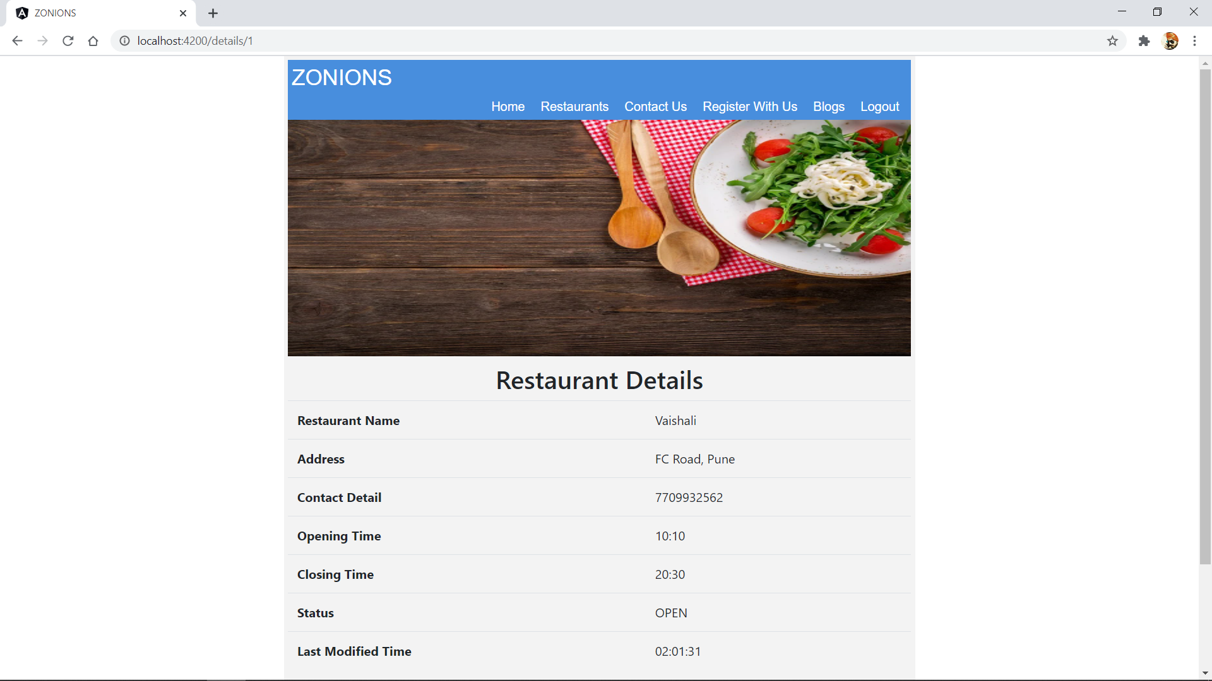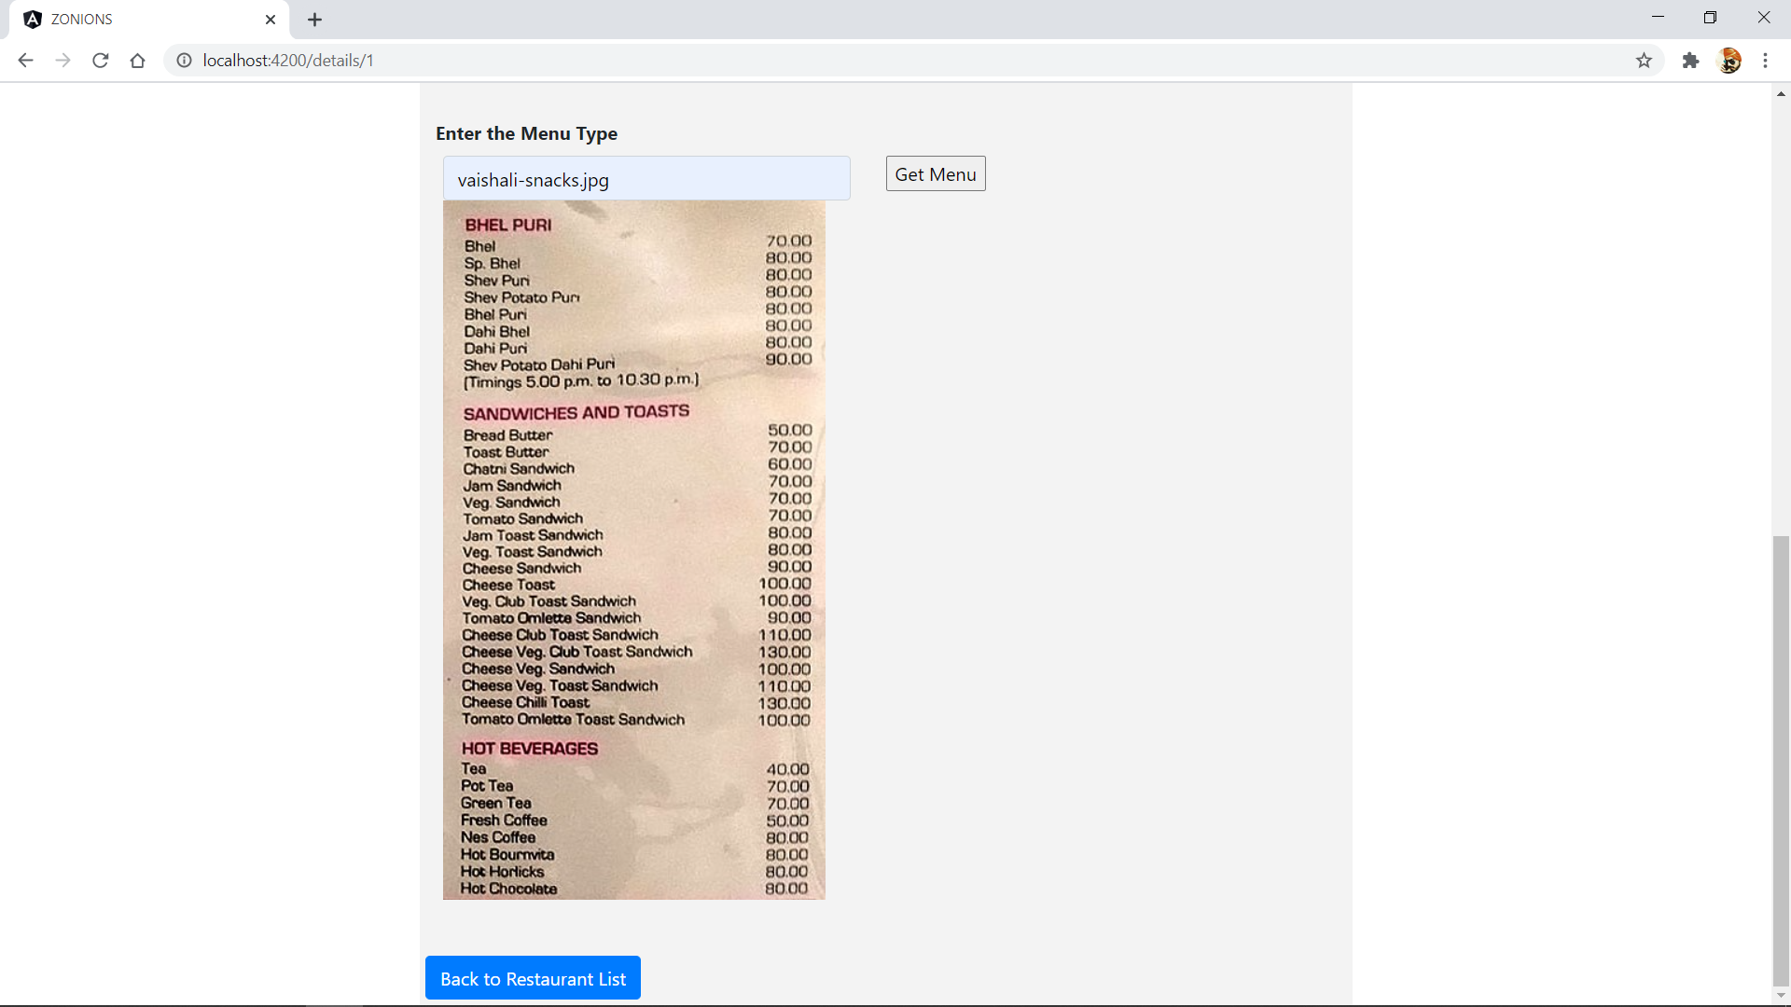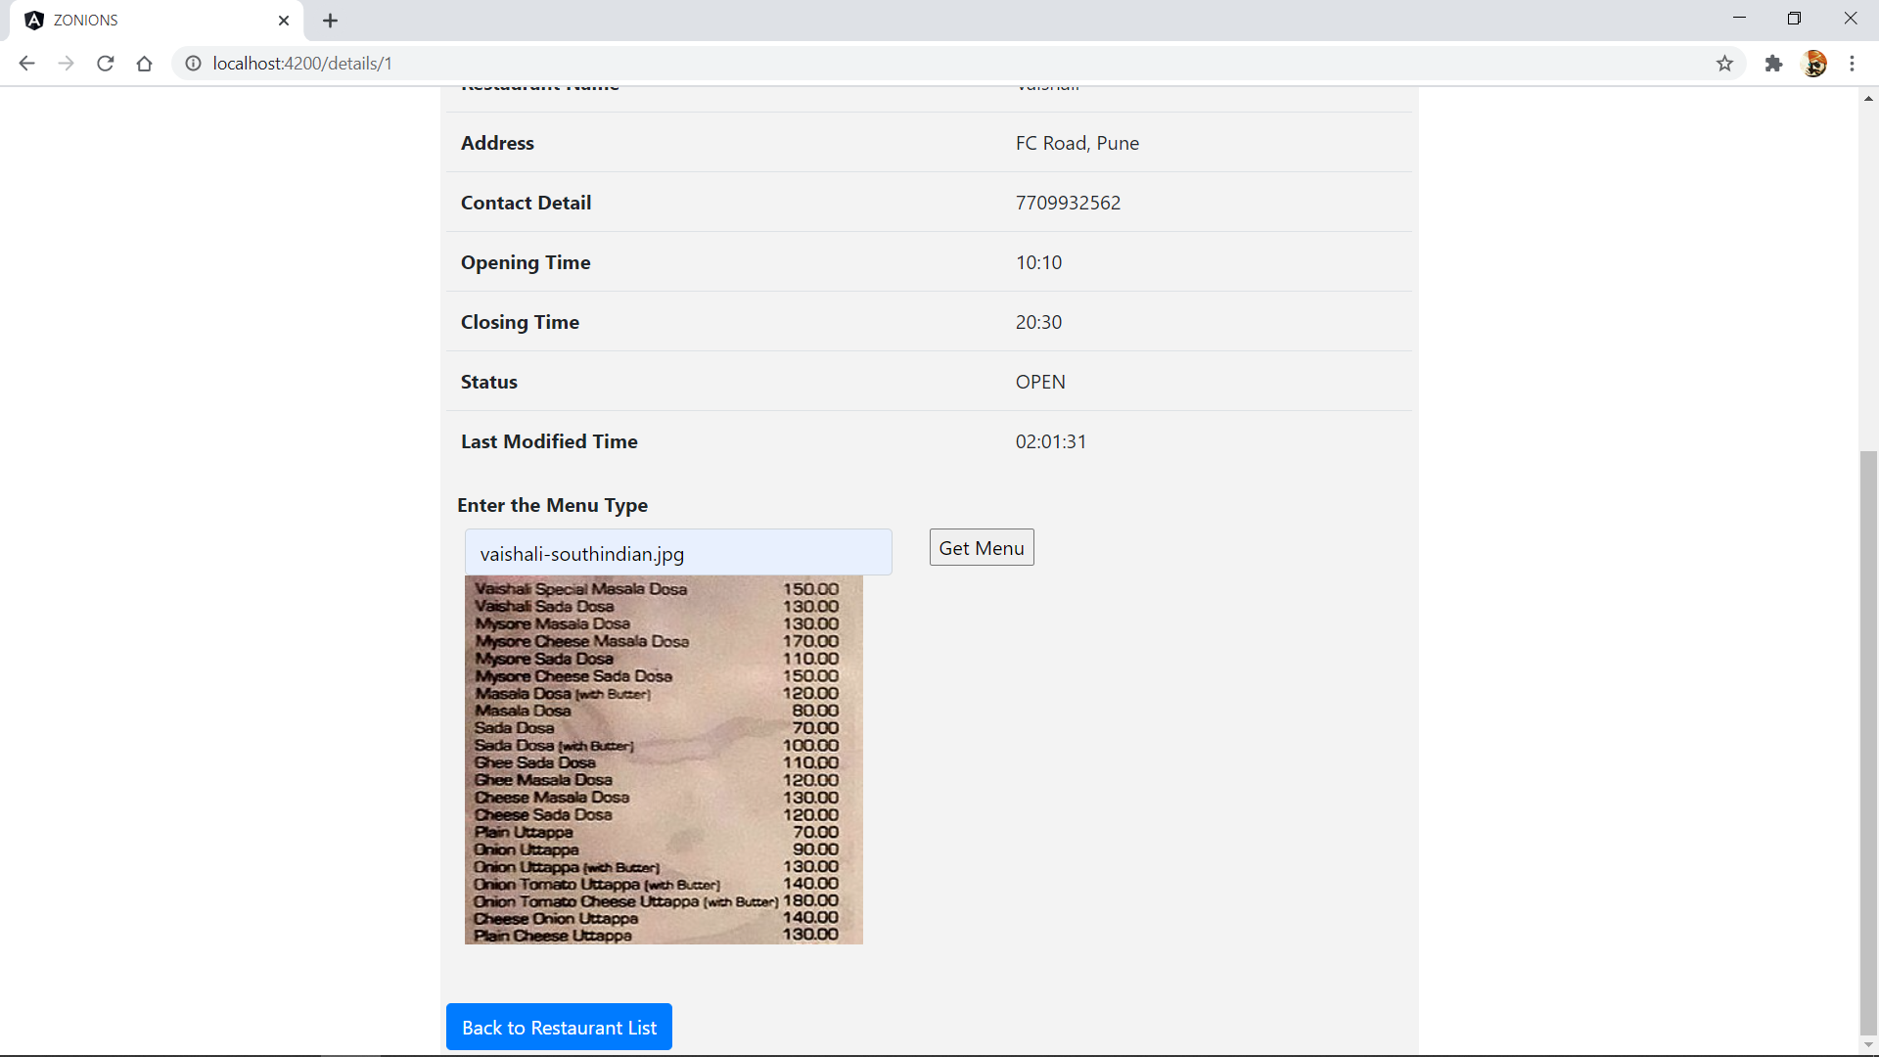

This page has all the details regarding a particular restaurant. Over here I have provided a Get Menu tab through which we can have a look at variety of menu of that restaurant.

For instance: 1) Snacks Menu 2) South Indian Menu

**Restaurant List Page**

On our top navigation bar, if we click on the **Restaurants**, then it will navigate us to Restaurant List page which consists of list of all active as well as non-active restaurants.

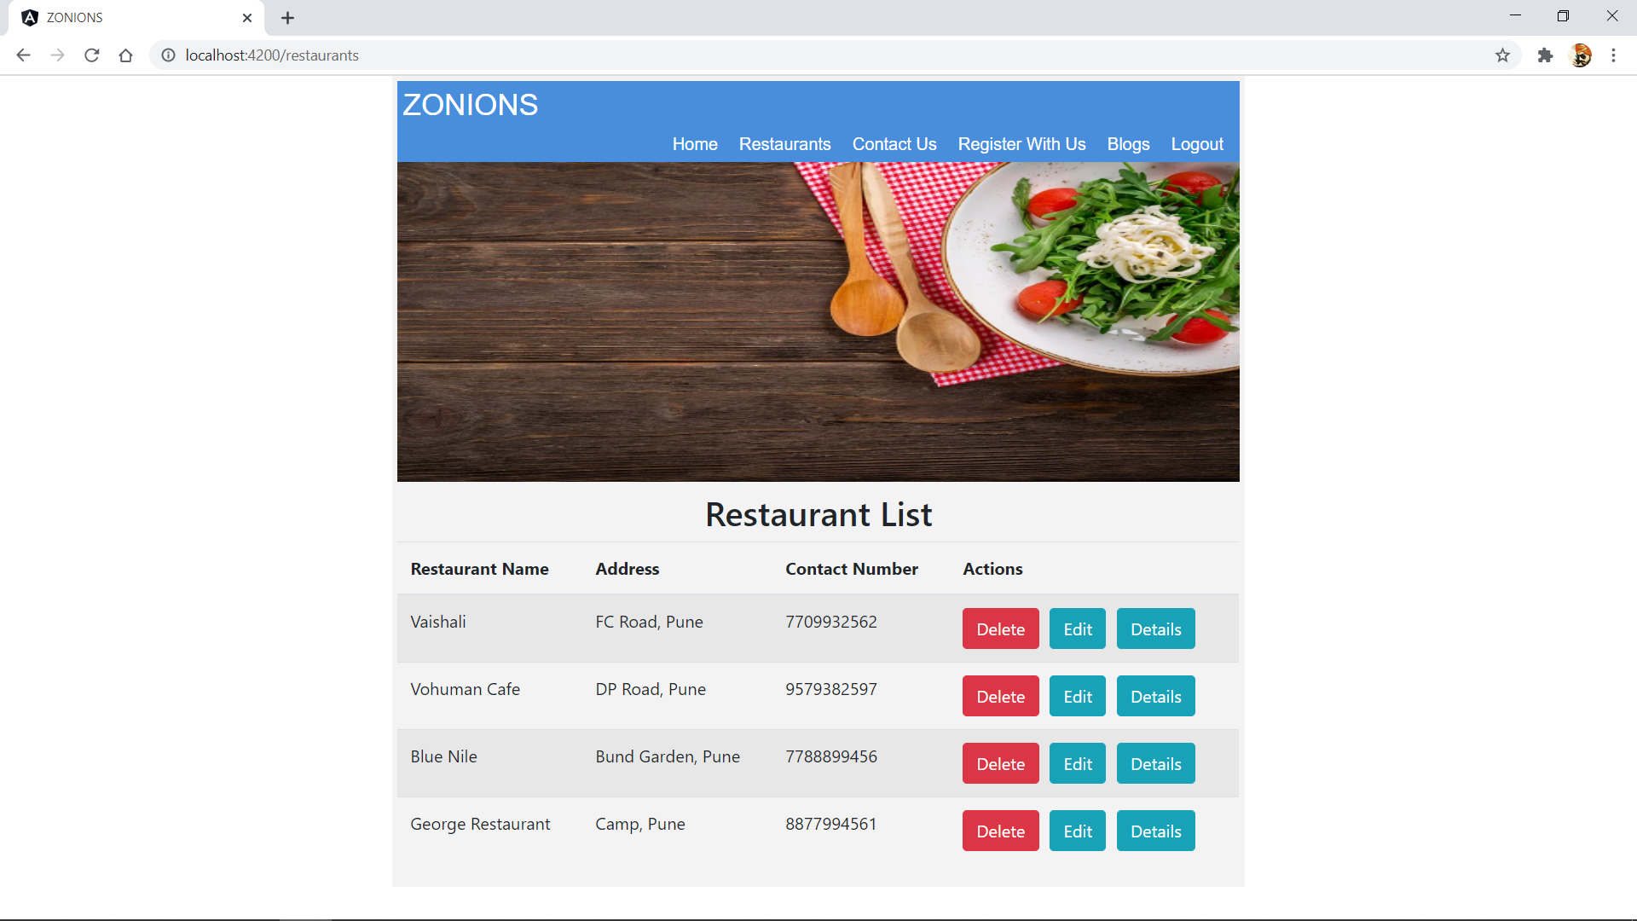

This page consists of **Delete**, **Edit** and **Details** tab. So, over here will can manage our restaurants. If we click on **Edit** tab then it will navigate us to Update Restaurant page.

**Restaurant Update Page**

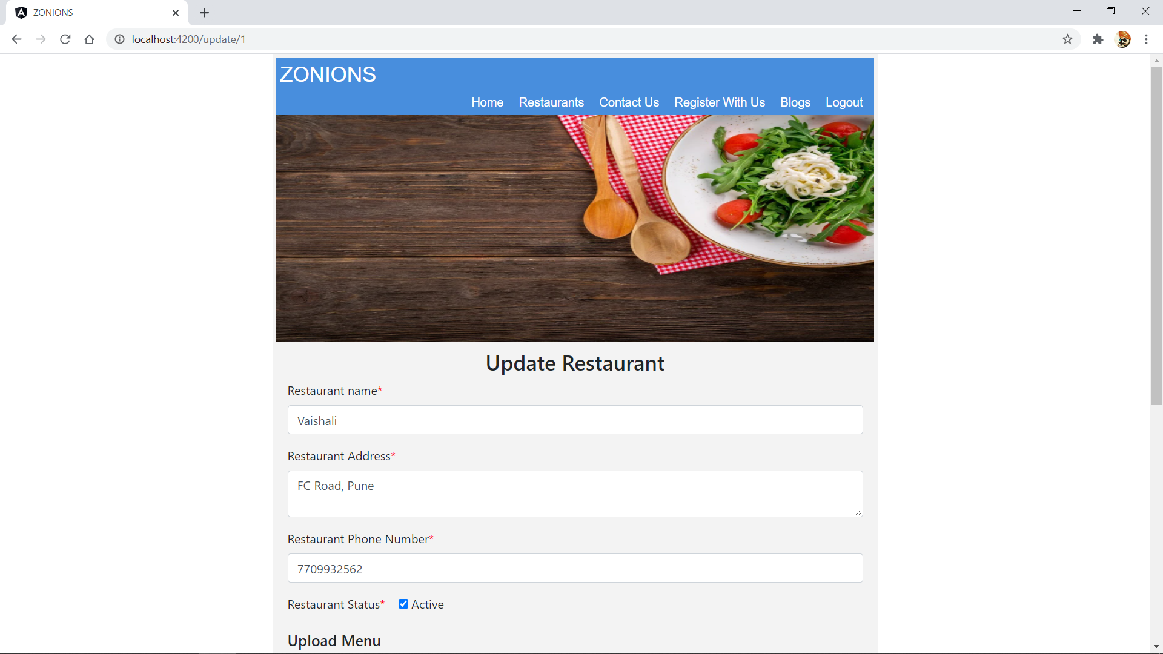

This page will let us manipulate the details of our restaurant. Now, on the top navigation bar if we click on **Register with us** tab then it will navigate us to **Add Restaurant** Page.

**Add Restaurant Page**

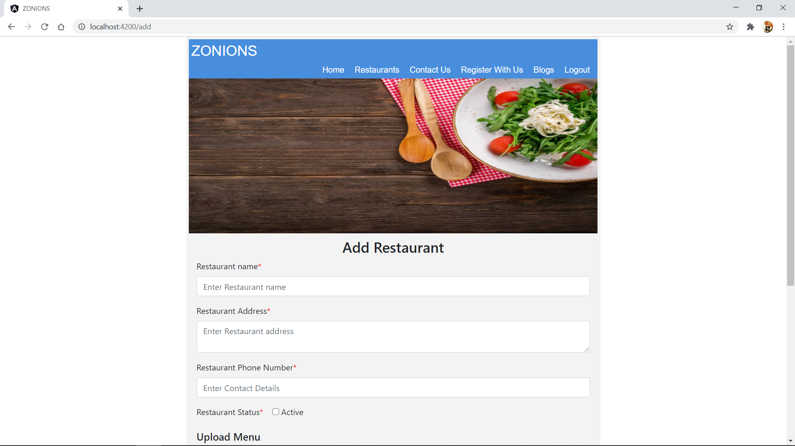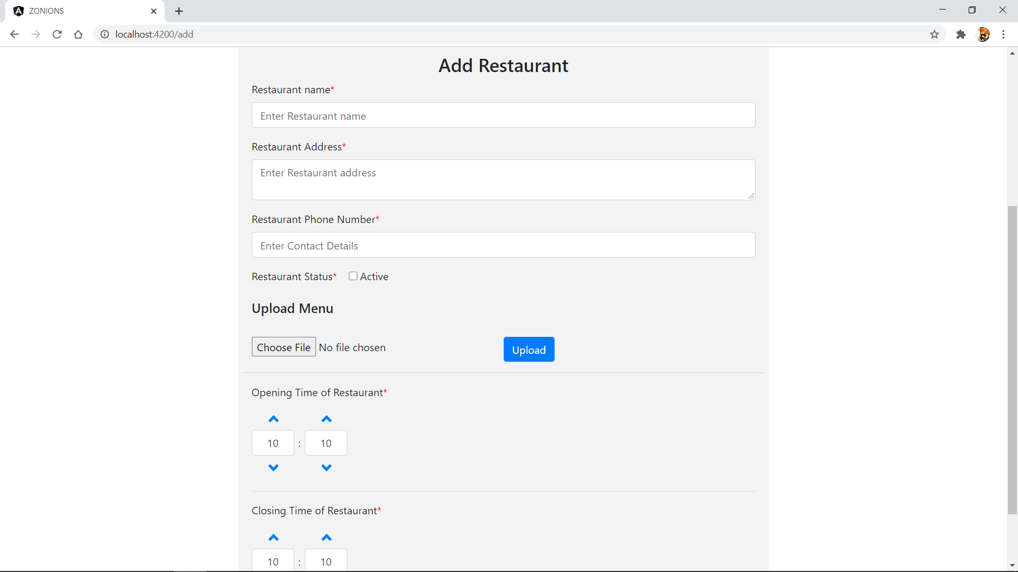

This page will allow us to add new restaurant.

**Logout Page**

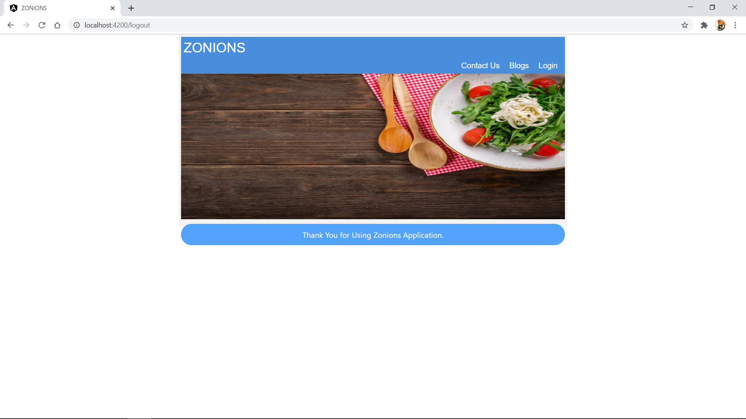

On the top navigation bar, if we click on **Logout** tab then it will navigate us to logout page.